1st bar :-
Logo and symbols with the nagarpalika name
2nd bar :-
Home Registration OnlineApplication Fee CallLetter Help login or register

Home page
Header : main photo , 2 regular moving bar with info of tollfree contact , one time registration is live
Noticeboard
Improtant Instructions
Quick link: how to register , how to apply , apply , admit card , results , help/ query

Registration tab:- apply edit find
Apply page (password)
Understanding Registration (has a detailed સમજ અને જાહેર સૂચના Insight & General Instructions) I agree button at end
Aadar card login
Personal Details (ઉમેદવારની માહિતી)
Communication Details (સંદેશા-વ્યવહારની માહિતી)
Other Details (અન્ય માહિતી)
Language Details (ભાષાની માહિતી)
Upload Photograph/ફોટો અપલોડ કરો
Upload Signature/સહી અપલોડ કરો
Declaration
Captcha
Save :- ( onces saved a registration unique id should be created (one Aadhar card one registration id))

Edit page:
Open for 48 or long ??
Find page:
Registration number or Aadhar card
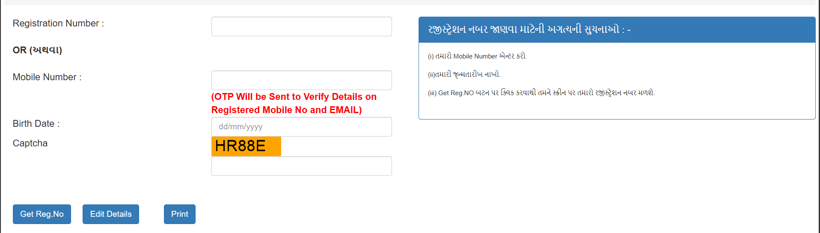

OnlineApplication tab :- apply , edit , print
Apply page
Select Advertisement by Department : (after selection list down the open posts to apply)
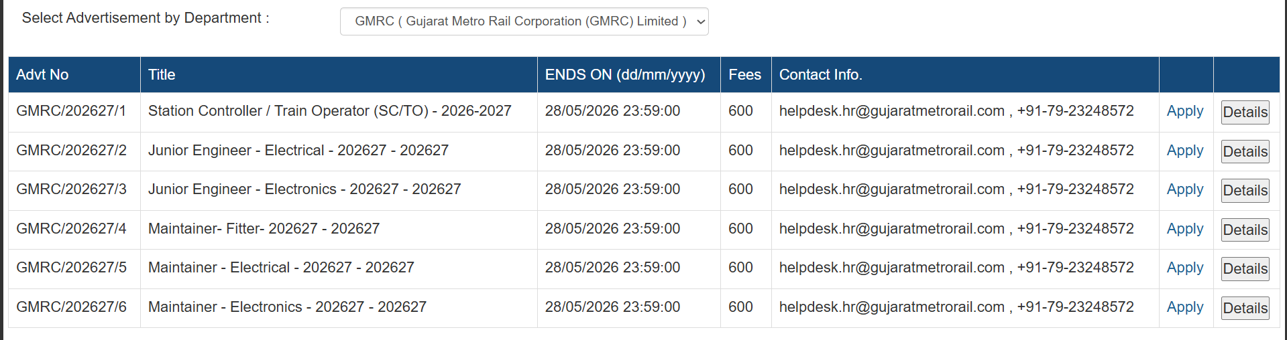
Details will have direct detailed pdf of that post
Apply opens:
Some basic details
Apply now
Click here for more details (goes to details pdf )
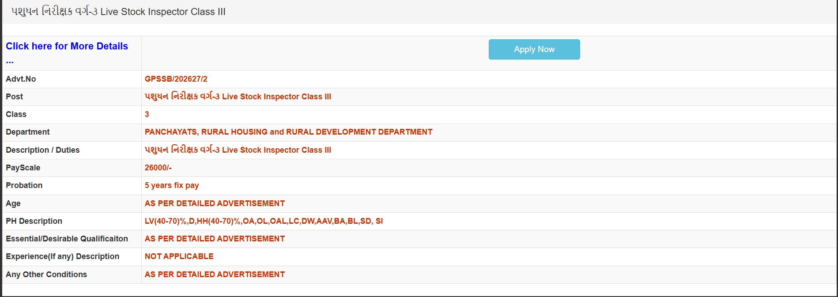

Apply now :
Registration num
Apply for OTR
Forgot registration num
Imp Instraction / suchana
